Design and Installation of a Video Conference Solution at the Center of Excellence in Remote Sensing Education and Research at Elizabeth City State University

Dr.Linda Hayden, Principal Investigator
Elizabeth City State University
1704 Weeksville Road, Campus Box 672
Elizabeth City, North Carolina 27909
Kevin Benton, Daquan Rascoe, Jefferson Ridgeway
Elizabeth City State University
1704 Weeksville Road
Elizabeth City, North Carolina 27909

Mr. Carlton Lamb, Mentor
Elizabeth City State University
1704 Weeksville Road
Elizabeth City, North Carolina 27909

Abstract—During the 2016 Spring Semester, the Research Experience Undergraduates Networking team project identified, evaluated, and implemented a video conference solution. The main objective was to establish a fully functioning video conferencing solution in four locations: Dixon-Patterson Hall, Rooms 226, 232 and Lane Hall, Rooms 111 and 119. To understand and create the scope of work for the project, the team had to research/analyze the rigorous standards, which are set in place by the International Telecommunications Union. This agency works directly under the authority of the United Nations and is charged with issues relating to information and communication technologies. The team examined the H.323 standard for Telemedicine, how Telemedicine has evolved, and how the H.323 standard has progressively changed the way we conduct our lives. After replicating the layout of the four spaces, the next objective was to identify and evaluate a software solution. After identifying and evaluating multiple video conferencing applications, the team selected a specific application. An example of an issue, which eliminated one application, was when an application indicated that a user would only have to open a link in the browser to be able to connect; but it did not indicate that the link would only work from within a certain browser. As for the hardware, the technical specifications of components were used to identify the hardware components. This method of selection, immediately gave preference to specific devices. The team also analyzed the history of video conferencing and how it has evolved. This research project enables the Center of Excellence in Remote Sensing Education and Research (CERSER) participants and invited guests to engage with others through video conferencing services.

Keywords—Networking, video conferencing, CERSER, ECSU

Introduction
There have been many advancements of technology throughout the course of time. One specific source of technology of which will be the team’s main focus is that of video conferencing tools. Video conferencing is a method of communication that incorporates both picture and audio simultaneously. Video conferencing goes as far back as the invention of television. With its upbringing of both simple and basic analog conferencing; it uses two closed circuit televisions connected with a cable (also called teleconferencing) [1]. Teleconferencing is a very important concept that plays a major role towards the development of video conferencing.
The use of teleconferencing was first introduced by Herbert Hoover in 1927, which is also the year that the first video conferencing tool called television was invented [1]. This event happened in 1927 between Washington DC and New York as Herbert Hoover’s image was sent by cables simultaneously as his voice was transmitted through phone lines [1]. This date and event serves a very important role towards video conferencing communication because of it being the first demonstration of video conferencing. However, the very first official peer to peer video conferencing device was the Picture Phone which was introduced in the1960s by AT&T in New York [1].
Currently, the elements of video conferencing are used as communication tools daily by people everywhere. Whether if it's for companies, organizations, or just your average person wanting to communicate through video conferencing. Video conferencing in today’s time is a collective deliverance throughout telephone or internet machinery which allows individuals of different location points to come in sync for a meeting through video conferencing (source2). Another aspect of video conferencing in today's time is that it can be between two individuals (peer to peer) or be associated between several sites with multiple individuals (multi-point) at different sites [1].
The practical setup of video conferencing involves both a camera which is for visual support/display and a microphone which is for the support of audio. Both the video and audio signals from the devices are converted to digital format and broadcast to a receiving location using a coding and decoding device (“codec) [1]. The type of cameras that the team used throughout the research were H.264 compliant. With the use of H.264 compliant cameras the team was able to acquire better video compression and video quality along with it’s lower usage of internet bandwidth than those of other video compression cameras such as MJPEG.
The team’s main objective is to establish a fully functioning video conferencing solution in four locations: Dixon-Patterson Hall Rooms 226, 232 and Lane Hall Room 111. Within the tested locations, the team observed specific characteristics that helped in distinguishing the best video conferencing quality, such as the network speed and network strength. The analysis helped the team to determine the leading location and video quality amongst each environment.

Objective
The team’s objective was to find a suitable video conference solution. This solution included a mixture of both hardware and software. The hardware component of the solution included cameras, microphones, and various other parts. The software component of the solution was to select the best fit for the video conference application and hardware. The intent was to establish a very stable and clear video conferencing session. This was very important to the team, because last year CERSER experienced various problems while hosting the video conference sessions. Thus the research group tested different variables that would affect a video conference solution. Some of these variables were network speed, network strength, compatibility, and ease of installation. This was done by testing various video conferencing software applications on different computers and in different environments.

Methodology
The team’s research comprised of gathering different video conferencing software solutions and collecting the most efficient solutions based on a selective criterion. Then the team tested the chosen software in different environments (Lane Hall 111, and Dixon-Patterson 226 and 232); while using different hardware to test. The hardware included using the Logitech Bcc950 camera and the Logitech cc3000e video conferencing system with new MacBook Air laptops. Used in a combination of wired and wireless connections to the internet. Both the Logitech Bcc950 and the cc3000e are systems that have, “H.264 with Scalable Video Coding (SVC)”, “convenient Bluetooth technology and Near Field Communication (NFC)”, and is said to be likely compatible with any software that is used regularly [2]. This system was purchased with the intentions of providing better audio and video quality from the receiving end of the host. New MacBook Air laptops were also included in the grant. These laptops allowed the team to test the video conferencing software on up-to-date computers and to identify potential issues that may arise.

A. Collecting Software
In collecting the proper software, the team was tasked with researching the most used video conferencing solutions of this age. A list was then comprised of ten different solutions and from this pool of software collected, the team picked the most current, efficient, and inexpensive solutions from that list. In order to render the list shorter to actually test software, solutions were removed based on the answers to the following questions: Is the solution inexpensive (or can be paid at one time without subscription service)? Is the solution compatible with different computers, laptops, smartphones, hardware, etc.? Is the solution user-friendly and efficient to use? After aanswering these questions the team was successful in removing seven of the solutions from the list. The three remaining solutions were used to test in different environments and situations: Google Hangout, Skype, and Join.Me. Google Hangout is a video conferencing solution that encompasses instant messaging with those who have hangout, video conferencing/calling, screen sharing, and regular voice calls. With video conferencing/calling, a user can “talk one-to-one or invite friends for a group chat with up to 10 people” [3]. The complete Google Hangout software package is free to use and is available on multiple platforms including android and iOS. Skype is another free video conferencing software solution that is also available to purchase with more bonus features from the paid version. Skype, like Google Hangout, allows the users to instant message those who have Skype, as well as call, and hold video conferences. On Skype, you can also screen share during a video call and share files as well [4]. Skype also works on a variety of different devices including tablets, smartphones, and laptops. Join.Me is solely a video conferencing solution that has both free and paid versions. The free version of Join.Me offers instant screen sharing and video conferencing and the availability of the software on tablets, smartphones, and laptops [5].
In understanding the functionality of the three softwares that were chosen from the shorten list, the team then prepared to test each of the softwares on the new macbook airs and smartphones, as well as the Logitech Bcc950 and cc3000e video conferencing system.

Selection Criteria
In testing software, there was a rating system based on rating each software according to the specific criteria. The criteria included: user friendliness, browser compatibility, ease of installation, number of seats, quality of video/stability, device compatibility, and screen sharing. In understanding if the software was user friendly, the team took into account how easy or difficult it was to maneuver the software from the perspective of a first time or novice user. The software was said to have browser compatibility, if the software worked on the most currently used browsers, which include Safari, Google Chrome, and Mozilla Firefox. The ease of installation is attributed to how easy it was to download the software or go to the website for a first time use. The Number of Seats refers to the number of attendees that can join the video the chat, which varied among the three softwares for testing. Quality of Video/Stability is relating to the clarity of the video for all of the users, using the video conferencing software. Device compatibility referred to seeing how well the software worked on different platforms from smartphones, tablets, and laptops. Screen Sharing is the ability for the user that is hosting the video conference session to share his/her screen with the rest of the attendees.
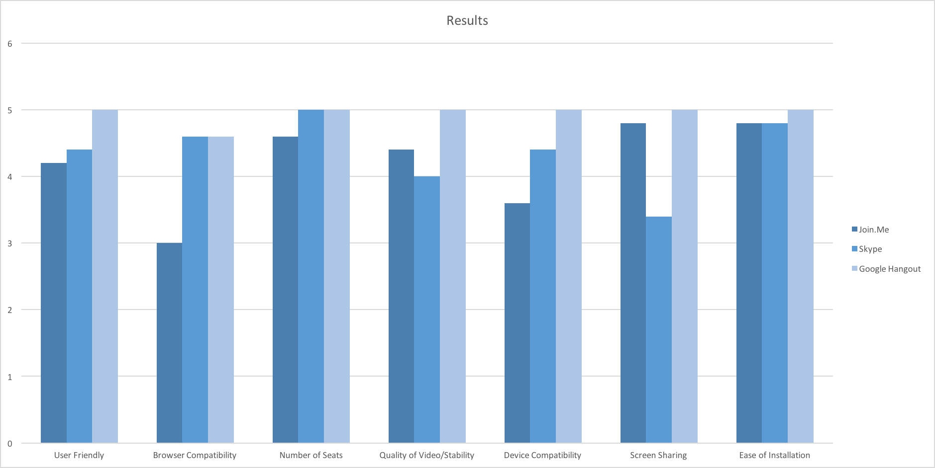
For each criteria, a rating was given by each of the members of the team, with 1 being the lowest rating and 5 being the highest rating. Another set of criteria was the network strength and network speed in each of those rooms. The numbers of the network speed (in Mbps, megabits per second) were determined by using the speedtest.net app created by Ookla, which is available on the android play store and the Apple app store [6].
While the network speed and network strength were not incorporated into the final criterion, the numbers and what the numbers mean hold significance about the internet connection at ECSU. The numbers corresponding to the network speed, include both download and upload speed. Download speed should be between 4-6 Mbps, “according to the Federal Communications Commission (FCC), this is the minimum speed ‘generally required for using today’s video rich broadband applications and services.’” [7]. Upload speed should be ideally “close to the speed your service provider associates with your plan” [7]. Network strength or signal strength is the “strength” of the wireless or wired connection to the internet on a specific device and the strength of a signal adds to the bandwidth. While it is difficult to obtain the number for the signal strength, by observing the strength of the signal on each of the devices, the team was able to conclude the overall moderate signal strength in each of the rooms that were tested.

Testing Software
In order to best simulate real-world environments with the video conferencing software, the team split up between Dixon-Patterson Hall, and Lane Hall, on Elizabeth City State University’s campus. All of the team members used the Macbook Air computers to conduct the testing of each of the softwares. However, not only were team members in different buildings and spaces, but some had a wired connection to the internet and others were using a wireless connection. Furthermore, the team tested the software with smartphones as well. Combining all of the possible different scenarios, each software was rated based on the rating system that was created within the team.

Analysis
After collecting and testing the three soft wares, Google Hangout, Skype, and Join.Me, the team then had to conduct the analysis of the findings from the rating system. The ratings of each team member were compiled and then averaged in an excel spreadsheet. Figure 1 shows what was gathered when Figure 2 shows the Network Strength at different points of the day.
Fig 1. Results of Findings
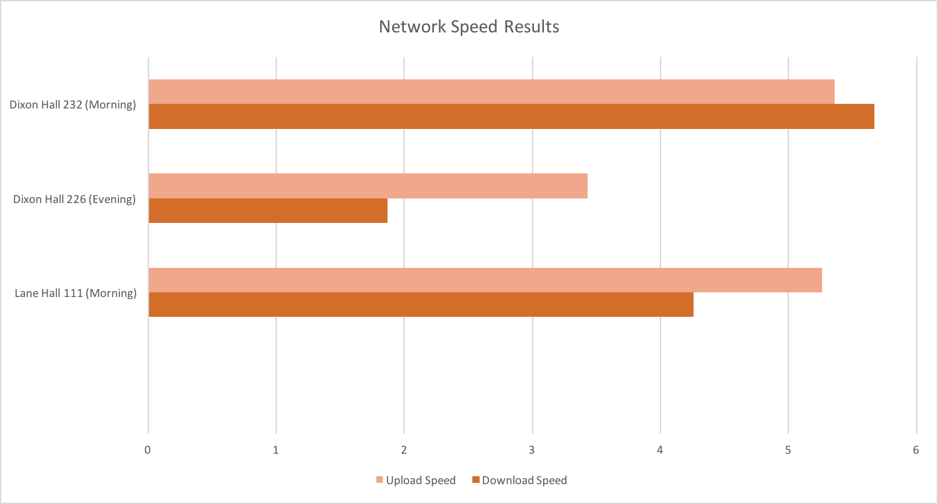

Fig 2. Network Speed Results
In gathering the data to form Figure 1, it is apparent that Google Hangout was the best video conferencing software according to the criterion set by the team. Google Hangout not only ranked highest on the criteria, but it has been used previously in classes at ECSU, therefore there is already a familiarity with the software. It has been used before by classes in Dixon Hall 226 in the past semester, and the results further solidify why it should continue to be used within the different buildings of ECSU’s campus. Observing Figure 2, it could be seen that in the morning in Dixon Hall and Lane Hall, there were both higher download and upload network speeds. The results affirm the notion that in the morning and afternoon, there are higher download and upload speeds because the students and faculty are not all on the network fully. However, it can be seen that in Dixon-Patterson Hall 226 from Figure 2, that late in the evening, the download and upload speeds are very low, meaning there is a higher usage within the population of the campus during the late time.

Conclusion
Based on the results from the findings and averaging the numbers from the rating system, Google hangout was rated the best among all of the criterion. The best time to do a video conference in either Lane Hall or Dixon-Patterson Hall would be in early morning to the mid-afternoon. Facilitating a video conference during this time period would yield the highest bandwidth through the network. While performing the research in the evening, it was apparent that due to “high traffic” on ECSU network, the network speed was not optimal, therefore the video (regardless of if it was connected to the internet wirelessly or wired), was pixelated and it was not as clear as when the traffic was not as high on the network.

Future work
In continuing this project, the hope is to enhance the environment in which video conferencing takes place. The focus will be to add better direct lighting in both Lane Hall and Dixon-Patterson Halls, and to add the signage of the university in the background of each video conference location. Furthermore, the research will seek a better audio system so that attendees can hear each other clearly and concisely. In the future, the research would continue to test Google Hangout on both wired and/or wireless connection to optimize the performance and experience for the users. In understanding that the team researched free options for video conferencing software, in the future, the research would potentially incorporate a fully paid version that would have a higher refresh rate which would mean a better quality of video compression so that the attendees would see each other clearly.

References

- M. Pourazad, C. Doutre, M. Azimi and P. Nasiopoulos, "HEVC: The New Gold Standard for Video Compression", IEEE Consumer Electronics Magazine, pp. 36-46, 2012.
- "Logitech CC3000e Video Conferencing System for 6-10 people", Logitech.com, 2016. [Online]. Available: http://www.logitech.com/en-us/product/conferencecam-cc3000e. [Accessed: 29- Mar- 2016].
- "Google Hangouts", Hangouts.google.com, 2016. [Online]. Available: https://hangouts.google.com/. [Accessed: 29- Mar- 2016].
- "Skype | Free calls to friends and family", Skype.com, 2016. [Online]. Available: http://www.skype.com/en/. [Accessed: 29- Mar- 2016].
- "join.me“ Free Screen Sharing, Online Meetings & Web Conferencing", join.me, 2016. [Online]. Available: https://www.join.me/. [Accessed: 29- Mar- 2016].
- "Ookla | The world standard in Internet metrics", Ookla.com, 2016. [Online]. Available: https://www.ookla.com. [Accessed: 29- Mar- 2016].
- "Interpreting Speed Test Results - Geek Squad", Geeksquad.com, 2016. [Online]. Available: http://www.geeksquad.com/do-it-yourself/tech-tips/interpreting-speed-test-results.aspx. [Accessed: 29- Mar- 2016].

